

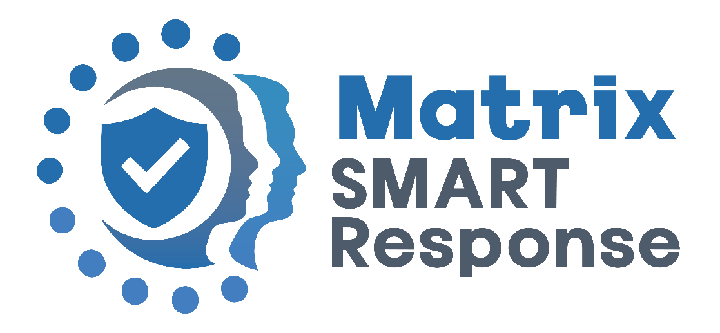

SMART Response® Procedures

Implementation date:
Last review date:
Next Review date:
Statutory Policy:
Date | Version | Reason for change | Source

NOTE: THIS POLICY SHOULD BE READ IN CONJUNCTION WITH THE BUSINESS CONTINUITY PLAN

Introduction to Matrix SMART Response®

At Matrix Academy Trust, we believe that school safety must evolve to meet today’s challenges. Our mission is to shape and influence national guidance by providing schools with a proactive, structured response to critical incidents, including lockdowns. SMART Response® was developed not only to improve immediate response but to change future legislation — ensuring all schools have consistent, practical, and tested procedures to protect students and staff.

The term ‘Lockdown’ is hugely emotive and triggers negativity; therefore, this procedure will be called SMART Response®. SMART Response® procedures should be seen as a sensible and proportionate response to any external or internal incident which has the potential to pose a threat to the safety of staff and pupils in the school. Procedures should aim to ensure the safety of all pupils and staff as far as possible until external agencies become involved.

Incidents can occur with or without warning. With warning incidents will trigger the Schools Critical Incident Plan and Critical Incident Management Team (CIMT). Without warning incidents are dynamic and fast moving and will be dealt with by the most appropriate person available working within the procedures detailed below.

SMART Response® will be triggered by activating the whole school SMART Response® Alert alarm and will end when a senior member of staff advises that SMART Response® is over.

Matrix Academy Trust has been working in conjunction with emergency services to develop new procedures to manage SMART Response® through a levelled approach as well as clearly identifying key roles to manage an incident.

Matrix Academy Trust is now part of the Advisory Board for MorServ, offering support and guidance to other establishments on lockdown procedures.

SMART Response® Training and Free Online Training Modules

SMART Response® is officially trademarked and designed using national crisis management procedures and government legislation. All content is supported by RoSPA-accredited modules. Our training is presented by Mark Wingett – an actor and advocate best known for his role in The Bill. Mark brings clarity and weight to the training, helping staff connect emotionally and practically with the real-life consequences of a poor or slow emergency response.

SMART Response® Training Modules:

- SMART Response® Introduction
- Module 1: Why Matrix SMART Response®?
- Module 2: The Levelled Approach
- Module 3: Roles and Responsibilities
- Module 4: Lockdown and Aftermath
- Module 5: Developing Practice into Policy
- Module 6: Example Scenarios
- SMART Response® & Martyn’s Law
- SMART Response® Procedures in Practice

Additionally, our complete suite of SMART Response® materials is available for free download:

- SMART Response® Policy
- Bronze and Silver Activity Cards
- Training Modules
- Multiple Choice Tests (Module Comprehension)
- SMART Response® Scenario Testing Template
- SMART Response® Premises Audit Template
- Communications Checklist
- Crisis Response Forms

Martyn’s Law & SMART Response®

SMART Response® has been developed in alignment with Martyn’s Law (The Protect Duty), ensuring that our schools are fully prepared for any emergency incident, particularly in relation to terrorism-related threats. Matrix Academy Trust has worked closely with emergency services and crisis management experts to ensure that SMART Response® adheres to the key principles of Martyn’s Law, including:

- Risk Assessment & Preparedness – Each site has clear procedures for assessing threats and taking proportionate action through a phased response approach (Levels 0-4).
- Staff Training & Awareness – All staff receive training in the SMART Response® procedures to ensure immediate, coordinated action in the event of an incident. In June 2025 Matrix Smart Response® Training has been accredited by RoSPA.
- National Training: From September 2025, Matrix Academy Trust will offer free training nationally via six video training modules through the Trust Website.
- Incident Management & Communication – Clearly defined Gold, Silver, and Bronze command roles ensure that emergency responses are structured, with communication channels in place for emergency services, parents, and key stakeholders.
- Drills & Testing – Schools regularly test and review their SMART Response® procedures, ensuring that all staff and pupils understand their roles in an emergency.
- Security & Access Controls – Measures are in place to secure perimeters, limit access, and control movement within school sites, aligning with Martyn’s Law requirements for public spaces.

With the public use of school buildings, including during lettings, additional risk assessments will be conducted, ensuring that security remains a priority when the site is used outside of core school hours.

Lettings & Out of Hours SMART Response® Crisis Management

SMART Response® is fully integrated into the Trust Business Continuity Plan, ensuring that procedures apply during and outside of school hours.

Key provisions include:

- Out-of-Hours Crisis Team – The Trust ensures that emergency contacts are available for incidents occurring during lettings or out-of-hours periods.
- Remote Access to SMART Response® Resources – Crisis teams can access emergency procedures, site plans, and key information via Dropbox, Microsoft Teams, and SharePoint, ensuring immediate response capability even when offsite.
- Martyn’s Law & Lettings Considerations – Schools that open their buildings for public use (e.g., sports halls, community meetings, external events) must have specific security protocols in place to reduce risk and ensure preparedness in line with Martyn’s Law.

All external users of school premises will receive emergency guidance as part of their lettings agreement to ensure they are aware of SMART Response® procedures.

By embedding SMART Response® across all areas of school operation, including out-of-hours use, Matrix Academy Trust ensures that all staff, pupils, and visitors remain as safe as possible, with robust emergency response structures in place.

a) There are two main types of SMART Response®:

1. LEVEL 3: External SMART Response®
This is in response to a threat that occurs outside the school buildings or site. This could be a report that a person or persons regarded as a threat by the police are in the vicinity of the school or an external health hazard such as a toxic cloud. In these cases, at least initially, normal practice can continue undisturbed within the buildings but the community needs to be alerted to the fact that they cannot go outside at breaks or lunchtimes or at any time until the all clear is given. The goal of this Level 3 SMART Response® is to prevent the threat from entering the building.

2. LEVEL 4: Full SMART Response®
This threat usually exists when the danger is inside a school building or on site. This could be an intruder or person whose intent on site has yet to established but is regarded as a danger to pupils or staff. This scenario involves a serious and immediate threat that requires urgent action. A SMART Response® is not a binary thing (off/on), it is a phased approach where any threat needs to be assessed through a levelled approach.
Please note: The Alert Alarm/Beacon system can only be activated by the Headteacher or a designated Senior Member of Leadership. The Phased Level approach must be conducted before the Alert system is triggered.

b) SMART Response® The Levelled Approach
Phased Approach: A full training video is available Module 2: The Levelled Approach

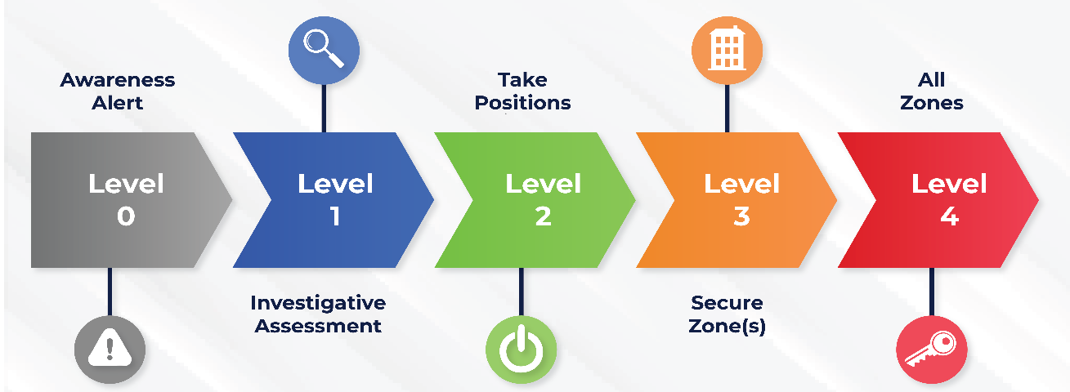

Level 0  Awareness Alert | Level 1  Investigative assessment | Level 2  Take positions | Level 3  Secure affected zones | Level 4  All zones
An incident is reported to the Headteacher or Senior member of staff.  A Live Risk Assessment of the incident is conducted to identify the threat level (if any).  CCTV is reviewed if available.  If the Headteacher feels that the ‘threat’ needs further investigation, they step up to Level 1. | The Headteacher communicates uses the Leadership radio the potential threat (for example; an intruder in Reception) “There is a Mr Grey in reception.” (Repeat)  An available member of the Leadership team checks CCTV in Headteacher office. (Command Centre).  If safe to do so a member of the Leadership team goes to area of concern to assess the threat.  If there is time, the member of Leadership is to contact the Headteacher (Duty SILVER) to discuss. If there is no time then go to higher level.  If the area of concern is all clear, step down to Level 0. An example radio cue for this is  “Mr Grey has left.” (Repeat)  If the area of concern is not clear and unsafe, step up to Level 2. An example cue for this is  “Mr Grey is here to fix the doors.” (Repeat) | The Site team to lock any unlocked building entrances.  The Leadership team to convene in Command Centre, with Head’s PA (Scribe) and Radio Operator.  Consider calling 999.  Members of available Leadership to collect BRONZE cards from the SMART Response® folder in the Command Centre.  If the threat can be isolated to one area then Cue to Level 3:  “Zone ___ Code Grey.”  If the threat cannot be isolated then  Cue to Level 4:  “Code Grey.” | Follow the SILVER and BRONZE procedures. | Trigger the Alert beacon system in the Command Centre, notifying the whole site of a full SMART Response®.  Follow the SILVER and BRONZE procedures.
 | Member of staff assessing the situation. “Keep yourself safe.” | What are they investigating

c) SMART Response® Team Roles

n policing (and in other public sector or military agencies), we adopt a command
Within these roles, a certain degree of restraint and discipline is required - i.e. staying
The Team roles require a certain degree of restraint and discipline is required (staying strictly in role).

Gold (Strategic) - sets the strategic intention and parameters
Silver (Tactical) - creates a plan that meets the Gold Strategy
Bronze (Operational) - individual roles, based on function or geography, that leads their part/function within the overall plan

There is only one Gold, one Silver and then multiple Bronzes. If I use a public protest as
There is only one Gold, one Silver and then multiple Bronzes.

GOLD:
The Gold is the CEO. They DO NOT sit with Silver or override the Silver's, but also need to support and guide the Silver.

The Gold:
- is responsible and accountable for managing the incident
- determines and sets the strategic objectives
- retains strategic oversight and overall command responsibility throughout the incident
- sets the tactical parameters of the incident but does not manage tactical decision making – this is the Silver’s responsibility
- sets, reviews, communicates and updates the strategy based on the threat assessment and available intelligence
- in response to a spontaneous incident, develops a working strategy into a formal strategy
- consults stakeholders when determining the strategy, including partner agencies and community groups as appropriate

SILVER:
The Silver should not be on the frontline - or anywhere near it. They should;
- establishes a command structure that is appropriate to the circumstances and sufficiently resilient and robust to achieve the strategy
- provides the pivotal command chain link between Bronze and Gold
- assesses the available information and intelligence to properly evaluate the threat, vulnerabilities and risk
- remains suitably located in the command centre to maintain effective tactical command of the incident
- ensures that all decisions and rationale are documented by the Scribe
- ensures that, where appropriate, all staff involved in the incident are briefed and debriefed
- considers the wider community, public safety and evidential implications of using certain tactics
- manages and coordinates, where required, multi-agency resources and activities
- ensures that any deployment is proportionate with the level of threat faced
- ensures that threat and risk, and impact assessment(s) are completed where appropriate
- considers command centre requirements and the communications structure for the incident
- coordinates the operational plans of Bronze

BRONZE:
- uses the Bronze command cards to fulfil their specific duties
- possesses clear understanding of the Gold strategy, the Silver tactical plan and their own role within it
- makes decisions within their agreed level of responsibility, which includes seeking approval for any variation in agreed tactics
- ensures staff within their area of responsibility are briefed and understand their role, responsibilities and limits
- updates the Silver on any changes, including any variation in agreed tactics within their geographical/functional area of responsibility

SMART Response® Flowchart of Team Roles and Responsibilities (Please see training video: SMART Response® Procedures in Practice)

Role | Responsibilities
GOLD:  CEO  (in their absence, the Deputy Headteacher) | 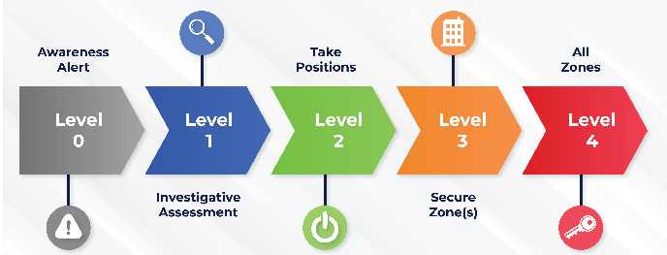
SILVER:  Headteacher | Manages the Threat assessment.  Contacts GOLD:  Contact: INSERT NAME  Call: INSERT NUMBER  If you cannot get through, email  INSERT EMAIL  Do keep trying to call.  If you cannot get through to INSERT NAME:  Contact: INSERT NAME  Call: INSERT NUMBER  If you cannot get through, email  INSERT EMAIL  Do keep trying to call.
Chief of Staff:  (Deputy Headteacher: in their absence, a designated assistant headteacher) | - Acts as the Radio Operator.  - Manages flow of information to SILVER, filtering where necessary.
Scribe:  Head PA  (or a member of admin) | - Takes detailed minutes of the operation.  - What happens, what is said, with time stamps.  - Monitors check sheet for BRONZE activity.
Bronze:  Emergency services communications.  Making METHANE report. | Emergency services will want the following information.  - Major incident  - Exact location  - Type of incident  - Hazards  - Access to Scene  - Number and Severity  - Emergency Services  Issues 999 Information card (x5) for emergency services about site, including how gates operate and locations of access points.  If safe to do so, once METHANE Report is made, meets Emergency Services and acts as Site Coordinator.
Bronze:  Communications with trust Director of School Improvement for press communications. | Contact: INSERT NAME  Call: INSERT NUMBER  If you cannot get through, email  INSERT EMAIL  Do keep trying to call.  He will for the details he needs to communicate with the press.  If you cannot get through to INSERT NAME:  Contact: INSERT NAME  Call: INSERT NUMBER  If you cannot get through, email  INSERT EMAIL  Do keep trying to call.
Bronze:  Communications with Central Office | Contact: INSERT NAME  Call: INSERT NUMBER  If you cannot get through, email  INSERT EMAIL  Do keep trying to call.  If you cannot get through to INSERT NAME:  Contact: INSERT NAME  Call: INSERT NUMBER  If you cannot get through, email  INSERT EMAIL  Do keep trying to call.
Bronze:  Parent communications | Sends messages to parents using messaging system.  Samples of text (to be adapted for the situation)  During the operation:  After identifying a potential risk, we are currently taking precautions to ensure no one can gain access to our site. Please do not come up to school as you will not be able to get in. Pupils are following our procedure brilliantly. We will update you shortly.  When returned to Level 0:  Someone tried to gain access to the school so we took precautions and the situation is under control. Police are dealing with the person. Full details will come later. Pupils were great.
Bronze:  Communications with neighbouring schools (within 1 mile) | Card has contact details of all neighbouring schools.  Samples of text (to be adapted for the situation)  During the operation:  As a neighbouring school we are contacting you to inform you that after identifying a potential risk, we are currently taking precautions to ensure no one can gain access to our site. Pupils are following our procedure brilliantly. We will update you shortly.  When returned to Level 0:  Someone tried to gain access to the school so we took precautions and the situation is under control. Police are dealing with the person. Full details will come later. Pupils were great.
When returned to Level 0:

Bronze:  Pupil and staff welfare Bronze | Deals with any pupil and staff welfare issues afterwards.

LEVEL 3: External SMART Response® Procedures for Pupils and Staff

These procedures are designed to secure the building from any external threat. Upon initially hearing the SMART Response® Level 3 Cue the full SMART Response® procedures should be followed (team roles). In this situation:
- Available Leadership report to the Command Centre to follow Team Roles and Responsibilities
- Remain calm but alert
- Keep all windows closed and building doors closed. Keep blinds closed
- Keep pupils inside, usually classrooms but this also might include common rooms or corridors if the situation is prolonged or over a break time and their visibility is not an issue, e.g. toxic cloud
- Continue to follow the timetable as far as possible unless informed otherwise
- Be prepared to follow further instructions as issued face to face by SLT or via email
- Pupils should not use a mobile phone at all; staff should be prepared to use a mobile phone if they feel the situation has developed further and information has to be relayed g. Keep pupils as calm as possible.
- Site Team members will secure areas of the school site that have been affected by the incident.

LEVEL 4: Full SMART Response® Procedures for Pupils and Staff

This procedure is designed to protect the community from any imminent threat. On hearing and seeing the SMART Response® signal (Alert System: Siren and Blue flashing lights), staff and pupils should do the following:

- Available Leadership report to the Commend Centre to follow Team Roles and Responsibilities
- Remain calm but alert – the site should fall silent immediately
- Collect pupils/make your way into a room within a building immediately. All corridors, toilets and communal areas should be clear. Do not allow pupils to visit the toilet
- If you are already in a room, stay there
- Close and if possible lock all windows and if safe to do so, staff to check that any building doors are closed
- Account for and keep together all pupils that are in your care
- Attempt to block the door with heavy items that are readily available e.g. desks
- Hide your staff lanyard into a pocket so that you could not be identified or required to open doors by an intruder
- Turn off all lights and close any blinds and curtains
- Keep pupils silent and inside classrooms, ideally seated on the floor in the least visible part of the room, out of sight of door vision panels as far as possible
- Be prepared to follow further instructions but only from a recognised/trusted senior member of staff or member of the emergency services
- Only use a mobile phone if you feel the situation has developed further and information has to be relayed
- Remain like this in the room with doors barricaded until you receive the all clear
- Ignore any fire drill unless you and your class are obviously at risk

d) SMART Response® Evacuation
If, as a last resort, if the school are instructed to evacuate a building leadership will send instructions via senior staff or members of the emergency services and ask staff to relocate pupils to a designated safe space (as identified within the Critical Incident Plan).

e) Appendix
- SMART Response® Levels
